Programming Assignment 4: Adjoint Methods
Mech 588
Due date: April 28
This assignment will explore some, though not nearly all, of the interesting uses of adjoint methods. The primal problem will be a Poisson problem in a square [0,1]×[0,1], with homogeneous Dirichlet boundary conditions on three sides (x = 0, y = 0, and x = 1); we’ll call the solution to the primal problem u and the solution to the adjoint problem v. Other details will vary for different cases. You can use any Poisson solver you have lying around (from 510, for example, or from the multigrid assignment) or write one from scratch.
- Warm-up problem. (Easy) For this case, the boundary condition at y = 1 is u = 0 and the source term for the primal problem is f 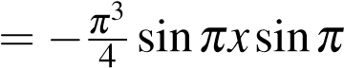y. For the dual problem, we also have homogeneous Dirichlet boundary conditions, with source term g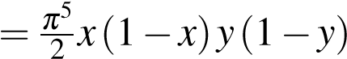.
The output functional in this case is
J = (u,g) = (v, f)
Solve both the primal and dual problems, and demonstrate that you get the same value for the (discrete) output functional evaluated both ways, and that the discrete output functional converges to its exact value at the order of accuracy of your numerical scheme.
To start, it would be best to calculate the functional analytically. In order to do this, we need the exact solution to the Poisson problem. We can determine this by inspection, or by using a change of variables. Let’s look at the exact solution to the primal problem, u. We notice that the source term in this case is
$$f=\frac{{-π}^{3}}{4}\sin\left(πx\right)sin⁡(πy)$$
The Poisson problem would be,
$$\frac{∂^{2}u}{∂x^{2}}+\frac{∂^{2}u}{∂y^{2}}=\frac{{-π}^{3}}{4}\sin\left(πx\right)sin⁡(πy)$$
We only have 2nd derivatives on the left side. For an arbitrary sin function,
$$h\left(θ\right)=sin⁡(πθ)$$
the 2nd derivative is given by,
$$\frac{∂^{2}h}{∂θ^{2}}=-π^{2}sin⁡(πθ)$$
Taking this, we can deduce that the exact solution of the Poisson problem must have the form,
$$u=\operatorname{asin}\left(πx\right)sin⁡(πy)$$
We can take the 2nd derivative of this function, with respect to x and y to obtain,
$$\begin{matrix}\frac{∂^{2}u}{∂x^{2}}=-aπ^{2}\sin\left(πx\right)sin⁡(πy) \\ \frac{∂^{2}u}{∂x^{2}}=-aπ^{2}\sin\left(πx\right)sin⁡(πy)\end{matrix}$$
We can plug this into the original problem to obtain,
$$-aπ^{2}\sin\left(πx\right)\sin\left(πy\right)-aπ^{2}\sin\left(πx\right)\sin\left(πy\right)=\frac{{-π}^{3}}{4}\sin\left(πx\right)sin⁡(πy)$$
We can rearrange as follows,
$$-2aπ^{2}\left(\sin\left(πx\right)\sin\left(πy\right)\right)=\frac{{-π}^{3}}{4}\sin\left(πx\right)sin⁡(πy)$$
Dividing both sides by $\sin\left(πx\right)\sin\left(πy\right)$ yields,
$$-2aπ^{2}=-\frac{π^{3}}{4}$$
We can solve for a to obtain,
$$a=\frac{π}{8}$$
Yielding an exact solution,
$$u=\frac{π}{8}\sin\left(πx\right)sin⁡(πy)$$
Now, we can calculate the functional as follows.
$$J=\left(u,g\right)=\int_{Ω}{u\left(x,y\right)*g(x,y)}dA$$
$$J=\int_{0}^{1}{\int_{0}^{1}{\frac{π}{8}\sin\left(πx\right)\sin\left(πy\right)\frac{π^{5}}{2}}x\left(1-x\right)y\left(1-y\right)dxdy}$$
Pulling out all of the constants,
$$J=\frac{π^{6}}{16}\int_{0}^{1}{\int_{0}^{1}{\sin\left(πx\right)\sin\left(πy\right)}x\left(1-x\right)y\left(1-y\right)dxdy}$$
We notice that this can be separated into two separate functions, w(x)c(y). We can separate the double integral into the product of two single integrals,
$$J=\frac{π^{6}}{16}\int_{0}^{1}{sin⁡(πx)x\left(1-x\right)dx}\int_{0}^{1}{sin⁡(πy)y\left(1-y\right)dy}$$
We notice that both of the single integrals are the same, just with different variables. We can use this property to rewrite the functional as follows,
$$J=\frac{π^{6}}{16}*{\left[\int_{0}^{1}{\sin\left(πγ\right)γ\left(1-γ\right)dγ}\right]}^{2}$$
Now, we only have to solve 1 single integral rather than 1 double integral to calculate the functional. Using integration by parts, and applying linearity we can obtain,
$$J=\frac{π^{6}}{16}*\int_{0}^{1}{\left(1-γ\right)γ\sin\left(πγ\right)dγ}=\frac{π^{6}}{16}*2\left[-\frac{\left(γ-1\right)γ\cos\left(πγ\right)}{π}\left|\begin{matrix}1 \\ \\ 0\end{matrix}\right.+\frac{1}{π}\int_{0}^{1}{2\left(γ-1\right)}\cos\left(πγ\right)dγ\right]$$
Again, we can apply integration by parts to obtain,
$$J=\frac{π^{6}}{16}*\left[-\frac{\left(γ-1\right)γ\cos\left(πγ\right)}{π}\left|\begin{matrix}1 \\ \\ 0\end{matrix}\right.+\frac{1}{π}\left\{\frac{2(γ-1(\sin\left(πγ\right))}{π}\left|\begin{matrix}1 \\ \\ 0\end{matrix}\right.-\frac{2}{π}\int_{0}^{1}{\sin\left(πγ\right)dγ}\right\}\right]$$
Finally, using u-substitution, we can obtain,
$$J=\frac{π^{6}}{16}*\left[-\frac{\left(γ-1\right)γ\cos\left(πγ\right)}{π}\left|\begin{matrix}1 \\ \\ 0\end{matrix}\right.+\frac{1}{π}\left\{\frac{2(γ-1(\sin\left(πγ\right))}{π}\left|\begin{matrix}1 \\ \\ 0\end{matrix}\right.+\frac{2}{π^{2}}cos⁡(πγ)\left|\begin{matrix}1 \\ \\ 0\end{matrix}\right.\right\}\right]$$
Evaluating the part within the brackets at γ=1 yields, $\frac{2}{π^{3}}$ Evaluating the same terms at γ=0 yields, $-\frac{2}{π^{3}}$. Thus, the functional can be evaluated as,
$$J=\frac{π^{6}}{16}*{\left[\frac{2}{π^{3}}-\left(-\frac{2}{π^{3}}\right)\right]}^{2}=\frac{π^{6}}{16}*{\left[\frac{4}{π^{3}}\right]}^{2}=\frac{π^{6}}{16}*\frac{16}{π^{6}}=1$$
Thus, the solution to the functional for this case is found to be 1. Similar results can be determined by evaluating the functional as J=(v,f), assuming the exact solution to the adjoint problem, v, is known.
To validate this for the discrete adjoint problem, the code provided on Canvas was modified, such that the boundary conditions and source term can be input into the function call. This allowed running of both the adjoint and the primal problem at the same time. A function was then written, which evaluated the functional using both J=(u, g) and J=(v,f). In order to evaluate the integral, 4-point Gauss-quadrature was utilized to determine u, v, f and g within each cell. These values were then multiplied for their respective functionals, and finally the value for each cell was multiplied by the cell area. Taking the summation of these values for each cell, should lead to an equivalent integral. The following screenshots demonstrate the output for the functional using both derivations, for a total of 40, 80, and 160 cells. It can be seen that the functional gives the same result, regardless of the formulation used.
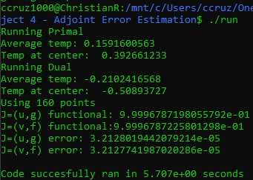
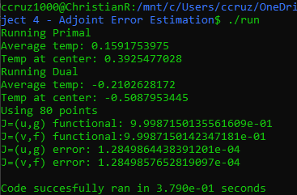
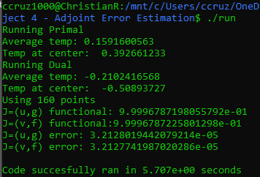
Finally, the following graph demonstrates the evolution of the error, as the grid spacing is refined.
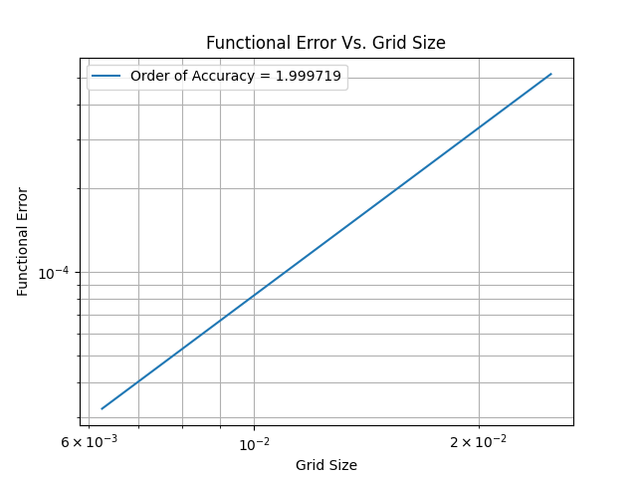

As can be seen, an order of accuracy of ~2 is found, which is expected, as the Poisson solver being used uses a 2nd order accurate discretization.

- Error estimation. (Medium) For the previous case, use a high-order (i.e., more than second order) discretization of the Laplace operator to compute the correction / error estimate term
$$δ_{j}=(LU_{h}-f_{h},v_{h})$$
In this case, your high-order operator will fill the role of Lu_{h} without any need for high order interpolation of the solution. Use your error estimate to get an improved value of the functional J and show that this corrected functional converges with a higher order of accuracy than the uncorrected functional.
- Functionals with boundary integrals. (Easy) For this case, use u = sin^{π}x as a boundary condition at y = 1; retain the same source terms as in Question 1. Your primal output functional is now
J = (u,g)_{Ω}+(u_{n},h)_{∂Ω}
1
where h = x(1−x) on y = 0 and zero elsewhere; keep in mind that u_{n} is defined as the directional derivative in the outward normal direction, so −u_{y} in this case.
It is easy to show that the dual problem in this case has a boundary condition of v = x(1−x) on y = 0, and v = 0 elsewhere, and that the dual functional is
J = (v, f)_{Ω}+(v_{n},e)_{∂Ω}
where e = sin^{π}x on y = 1 and zero elsewhere.
Compute this functional using both the primal and dual problems, and show that this formulation is adjoint consistent and converges with the correct order of accuracy.
- Sensitivity. (Medium to hard) Suppose now that we modify the primal problem from Question 1 so that
f 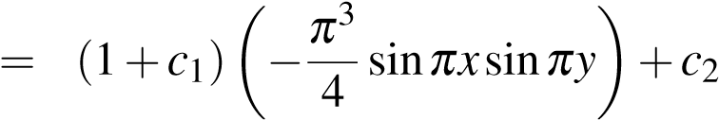g
In the context of an optimization problem, we would need to be able to compute 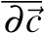^{∂J}. Writing this partial derivative out using the chain rule:
J = (u,g)_{Ω} = J(u(~c))
∂J ∂J ∂u
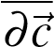
= (1)
∂~c ∂u
This would require an additional primal solve to estimate the derivative of the solution with respect to each component~c. But we can take advantage of the zero-residual condition:
L(u) = f
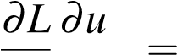 ∂f ∂u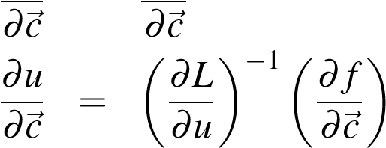
This doesn’t reduce the amount of work yet, but substituting this into Eqn. 1 and taking the transpose does:
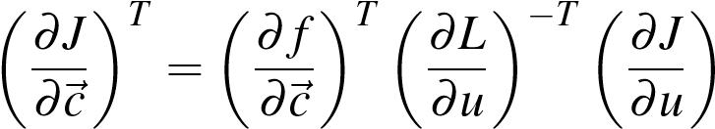T
where the last two terms represent the solution to the adjoint problem with 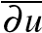^{∂J} as a source term.
Use the adjoint formulation to find the sensitivity of this objective function for c₁ = 0, c₂ = 0.5; use finite differences to verify your sensitivity result.
2

Note that my experiments suggest that this level of approximation, while successful here, isn’t sufficient for error estimation for functionals with boundary integrals.

